Serious scholarship serving academia since 1975.
University Press of America, ® Inc.
4501 Forbes Blvd., Suite 200 Lanham, Maryland 20706 · 1-800-462-6420 · www.univpress.com

FOR IMMEDIATE RELEASE
Publicity Contact: Lisa McAllister
lmcallister@rowman.com or 301-459-3366 X5619
____________________________________________________________________________________________
Bastille Witness
The Prison Autobiography of Madame Guyon
(1648-1717)

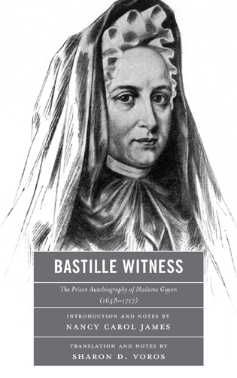
This translation of Madame Guyon’s prison autobiography provides a compelling account of her eight years of incarceration from 1695 to 1703. Her style is conversational and personal with a keen sense of spirituality in the midst of adversity. Madame Guyon’s lack of formal education, which was not offered to women especially in matters concerning theology, caused her published works to become suspect, confiscated, and condemned. These memoirs were never published in her lifetime and only came to light when the French scholar Marie-Louise Gondal identified the manuscript as a copy of the fourth part of her autobiography. Madame Guyon consistently maintained that she was innocent of all charges. She shows great courage and faith in these prison memoirs that shed light on her most difficult years, including the interrogation practices, the criticism of her writings, and the circumstances for her release. This text is a testimony to her perseverance and a tribute to her writing ability in those times of stress and constant humiliation.

_____________________________________________________________________________________
Nancy Carol James received her PhD from the University of Virginia and wrote her dissertation on Madame Guyon. She serves as priest associate at St. John’s, Lafayette Square, Washington, D.C.

Sharon D. Voros, professor of Spanish and French at the United States Naval Academy, holds a PhD from Columbia University in New York City. Her current scholarship focuses on seventeenth-century women writers in Spain and France.
_____________________________________________________________________________________
UNIVERSITY PRESS OF AMERICA
An Imprint of The Rowman & Littlefield Publishing Group
https://rowman.com/ISBN/9780761857730
December 2011  140 pages
978-0-7618-5772-3  $50.00  Cloth
eBook Available

